 | Workshop Title | Date | Time* | Location
 | Time Management for University | Tues. Jan. 9 | 4:00 p.m. | LA274
 | Build Your Study Schedule | Wed. Jan. 17 | 3:30 p.m. | LA297
 | Get the Most Out of Reading | Thurs. Jan. 18 | 12:00 p.m. | LA271
 | Notetaking and Listening in Class | Tues. Jan. 23 | 2:30 p.m. | LA177
 | Effective Study Strategies | Wed. Jan. 24 | 11:00 a.m. | MM227
 | Overcome Procrastination | Mon. Jan. 29 | 1:30 p.m. | AT216
 | Focus and Concentration | Thurs. Feb. 1 | 11:30 a.m. | LA188
 | Time Management for Busy Students | Wed. Feb. 7 | 2:30 p.m. | MM227
 | Boost Your Motivation | Fri. Feb. 9 | 11:30 a.m. | LA282
 | Writing Tests and Exams | Wed. Feb. 14 | 1:30 p.m. | AT216
 | Overcome Procrastination | Tues. Feb. 27 | 11:30 a.m. | AT340
 | Learning Supports for ‘Neurospicy’ Students | Tues. Feb. 27 | 3:30 p.m. | AT340
 | Mind Mapping for Learning and Memory | Thurs. Feb 29 | 12:30 p.m. | AT340
 | Time Management for Commuters | Thurs. Mar. 7 | 2:30 p.m. | LA177
 | Boost Your Motivation | Tues. Mar 12 | 3:30 p.m. | LA177
 | Effective Study Strategies | Mon. Mar. 18 | 4:00 p.m. | LA177
 | Preparing for Science Exams | Wed. Mar. 27 | 5:30 p.m. | AT216
 | Build Your Study Plan | Tues. Apr. 2 | 4:30 p.m. | LA177
 | Writing Exams | Thurs. Apr. 4 | 11:30 a.m. | LA188

*All workshops run for 45 minutes
*Workshop location subject to change. Visit www.smu,ca/studentsuccess for updates!
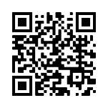
Join us for free in person or online (Zoom)
Learn more and register at www.smu.ca/studentsuccess
Walk-ins are welcome!
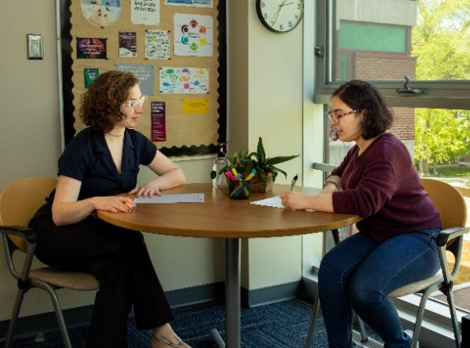
Meet one-on-one with Learning Skills Strategist, Emma Sylvester, to discover learning approaches that will work best for you. Get support in:
- general study skills  - time management  - exam preparation  - notetaking | - procrastination  - motivation  - focus  - and more!

Appointments are free and are offered both in-person in the Student Centre, SC301, and online.
Book a one-on-one appointment at www.smu.ca/studentsuccess or email StudentSuccess@smu.ca

Learning Skills  and Strategies | Study Hall
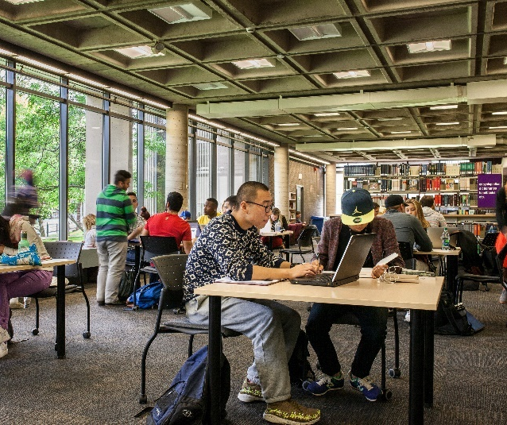
Study Hall is a free, open, shared workspace for you to:
- work effectively
- grab a study snack
- meet and study with peers
- get support on your exams and assignments
- use provided tools and materials
Held every Thursday, 1:30 - 3:30 p.m. in the Patrick Power Library Classroom, LI135

