Under “Colonialism & Migration: Ancient & Modern” Field School
Archaeological Field School in Italy
Metaponto Archaeological Project
May 15-19: remote delivery; May 21 -June 10: in the field in Italy
(ANCS 3610 and 3611 OR ANCS 4610 and 4611)

The Metaponto Archaeological Project
Under the dual stream field school “Colonialism & Migration: Ancient & Modern”, the Metaponto Archaeological Field School will carry out excavations at Incoronata “greca” (Pisticci, Matera, Italy), an Indigenous-Greek settlement near the Ionian coast. The field school presents learning and research opportunities for students at an active archaeological site in Basilicata (Italy) conducted under the auspices of the Italian Ministry of Culture. It will be delivered in partnership with the Migrant Justice Field School (MJFS) directed by Dr. Val Marie Johnson.
It will run during the Summer Session and include 4 weeks of activities:
- Week 1 (May 15-19) will allow for preparatory course reading and synchronous virtual classroom work;
- Week 2-4 (May 22-June 10) will be delivered on-site in Italy.
Students will enroll in two 3.0 credit hour courses (tot. 6.0 credit hour courses) (ANCS 3610, Field Study in Roman Archaeology and 3611, Roman Archaeology Field Laboratory or ANCS 3610, Advanced Field Study in Roman Archaeology and 3611, Advanced Roman Archaeology Field Laboratory) offered by Saint Mary's University through the Department of Languages and Cultures. The archaeological project is a partnership with Dr. Spencer Pope (McMaster University) and includes an international team with specialized expertise from Italian, Canadian and North American Universities.

The Site | 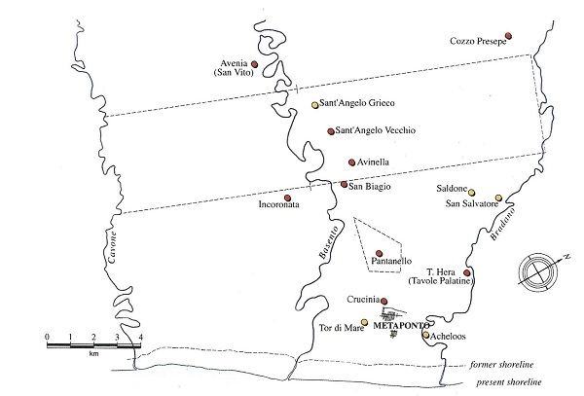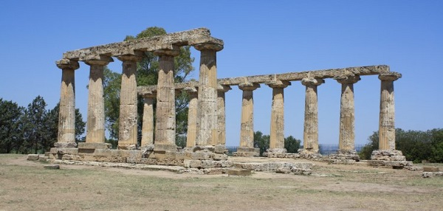
The ancient Greek colony of Metaponto was founded towards the end of the seventh century BCE in what is today Basilicata, located on the instep of the boot of the Italian peninsula. Prior to the foundation, the territory of Metaponto was home to thriving Indigenous communities with whom the Greeks established contact in the 8th c. BCE. The formal foundation of the city entailed the appropriation of a vast territory called the chora, which amounted to over 400 km². This land had many functions but, above all, was used for agricultural production including grain, vines and olive groves. Accordingly, it was occupied by farmsteads, necropolis and sanctuaries. The Greeks frequently built sanctuaries in the chora that intended to integrate the city and the countryside as two complementary halves of the community. The best-known among them at Metaponto is the so-called Tavole Palatine, a sanctuary of Hera, where an archaic Doric temple still stands today.

The Project | 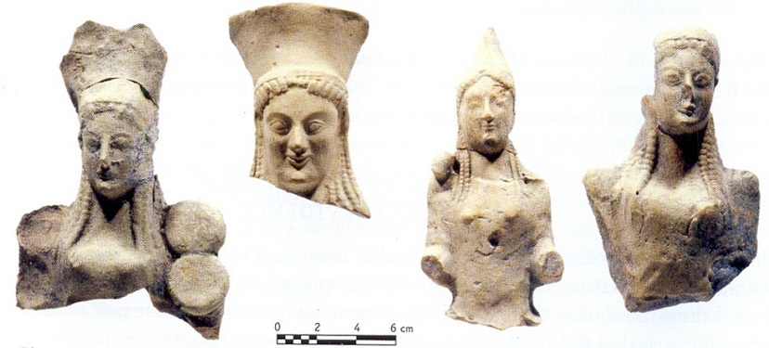
The Metaponto Archaeological Project aims to reconstruct settlement patterns and to document occupation in the surrounding landscape through field survey and archaeological excavation. Excavation is programmed at Incoronata “greca”, a site frequented between 9th and 7th c. BCE by Indigenous Populations (the Oenotrians) and Greek Settlers. The hilltop was again occupied in c. 550 BCE, this time as a Greek sanctuary dependent upon Metaponto. From an Indigenous stronghold in the late Archaic period, Incoronata “greca” appears to have been completely integrated in the sphere of the Greek city.

Activities
- In Week 1, students will conduct preparatory readings and synchronous virtual classroom activities to become familiar with the history and archaeology of the region and to address the theoretical aspect of archaeological field work.
- Once on site (Week 2, 3, 4), students will learn every aspect of the archaeological work: excavation, field survey, territorial studies, and GIS applications in archaeology. The training includes the identification, restoration and cataloguing of material artifacts as well as data management (7am to 4 pm). Daily activities will be divided between excavation and managing finds. In the warehouse, they will include washing and analyzing pottery, updating the database, updating GIS files, as well as photographing and drawing finds. Students will rotate through a range of tasks in order to build familiarity with all aspects of archaeological data management. The historical background of colonialism and migration in the Western Mediterranean Sea will be examined and discussed through lectures and visits to archaeological sites in Basilicata and Calabria (including the Archaeological Museum in Metaponto, the Metaponto Archaeological Park, the Archeological Museum of the Siritide, etc.); a continuous exchange with SJCS students will allow comparisons between ancient and modern migratory dynamics.

In Italy: Living Arrangements and Logistics
From May 15 to June 10, 2023, students will be housed at the Agriturismo Il Calanco, located in the countryside of Pisticci. Students will stay in shared bedrooms (3-4 persons per room) and share a bathroom (one per room). Common spaces in the house include a patio and a swimming pool. Breakfast and evening meals are provided for the team Monday through Sunday by the Agriturismo Il Calanco and are usually enjoyed together (a standard menu will be provided weekly). It will be possible to accommodate vegetarian diet. Because meals are served family style, we are not able to accommodate vegan diets.
Lunch will be provided Monday through Friday from a local deli and eaten on-site. Students are on their own for any snacks consumed across the day and lunches on Saturday and Sunday.
For weekend lunches, students could rely on the services provided by the Agriturismo or eat on their own (in many cases weekends are spent visiting sites). In any case, transport will be provided to do food shopping.
Accommodations at a glance:  - Shared bedrooms with single beds (3-4 persons per room)  - Shared bathrooms with shower (no bathtubs)  - Sheets/towels/pillows/blankets provided  - Washing machine with racks for drying clothes | 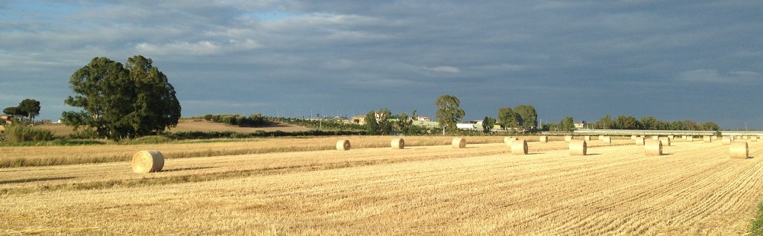

The Area
The Agriturismo is located in a rural area and accessed by car. Pisticci is the fourth most populous town in the region, and it is known for being the production site of Amaro Lucano, one of the most famous Italian liqueurs. Modern Metaponto is a small town that is home to the Regional Archaeological Museum, supermarkets, cafes and a pharmacy; it also has a beach resort that is busy during the summer. Metaponto has bus and rail service to many sites in Southern Italy: Matera and Taranto are major cities that can be accessed in c. 1 hour. Rome is a six-hour train ride to Metaponto. Students are encouraged to travel on weekends: potential destinations include Taranto, Matera, Potenza, Bari and Lecce. Matera, the second largest city of Basilicata, was named “European Capital of Culture” for 2019 and has numerous museums and exhibitions. Basilicata is home to number of charming towns that merit exploration: Craco, Policoro and Montescaglioso all make for pleasant daytrips. Please note that all travel expenses are the responsibility of the student.

Fees and Costs
- The Project has a program fee of CAD 1,990 (approx.), which covers costs associated with the field school, including three meals a day (from Monday to Friday) and two meals a day (from Monday to Sunday), accommodation, and transport to and from the site each day.
- The tuition for the two courses (6.0 credit hours) are CAD 1,986 (total).
- NOT INCLUDED IN PROGRAM FEE: Students are responsible for the additional costs of travel from Canada to Metaponto (including for R/T flight Canada to Italy and R/T train travel from Rome to Metaponto). In general, student airfare to and from Italy during the summer runs between CAD 1000 and 1500 (depending on the point of departure, airline, and route) and the train travel R/T from Rome to Metaponto is around CAD 200. Depending on the connection between flight and train, students should budget for the cost of 1 or 2 nights of hotel in Rome (c. CAD 120/night). Students should also anticipate costs for travel and emergency health insurance, breakfasts, snacks, lunches on the weekend, along with any other incidentals and other travel within Italy.

Course Credit
Students will enroll in two 3.0 credit hour courses (CLAS 3610, Field Study in Roman Archaeology and 3611, Roman Archaeology Field Laboratory) offered by Saint Mary's University through the Department of Languages and Cultures. Taking the courses necessitates registration and requires additional tuition fees. The tuition for the two courses (6.0 credit hours) are around CAD 1,986 (total). Enrolled students will be evaluated on the basis of attendance, participation, a daily journal, an on-site presentation and a final paper/presentation based on their experience. Those students with previous archaeological experience may take the course at the 4000-level (CLAS 4610 and 4611).

Prerequisite
The prerequisite for the field school (CLAS 3610 and 3611) is 3.0 credit hours of archaeology through a Classics or Anthropology Department, or 3.0 credit hours in Classics, or permission of the instructor. The course is not designed specifically for those majoring in Classics or archaeology and is open to all students at Saint Mary’s University. Those students with previous archaeological experience may take the course at the 4000-level (CLAS 4610 and 4611).

Travel Considerations
-Students must obtain travel insurance prior to departure; most banks offer economical insurance packages
-Italy has 220 volt current so electrical adaptors are necessary for most appliances
-Italy is five hours ahead of Atlantic Standard Time
-Students may want to purchase an Italian or international SIM card (with data plan) for unlocked cell phones

Contact information:
Project Director:
Dr. Sveva Savelli, Dept. of Languages and Cultures, Saint Mary’s University; Sveva.Savelli@smu.ca
Cellphone in Italy (dialed from Canada) 011-39-338-353-2359.

Suggested reading on Metaponto, Basilicata, and Southern Italy:

J. Carter, Discovering the Greek Countryside at Metaponto, Ann Arbor: U. Michigan Press, 2006
J. Davis, Land and Family in Pisticci, 1973
C. Levi, Christ Stopped at Eboli
www.matera-basilicata2019.it/en/

Application Process
If you are interested in applying to participate in the 2023 field school, please fill in this form and send it back ASAP to Dr. Sveva Savellli, Department of Languages and Cultures, Saint Mary's University, Halifax, NS, Canada, via email at: sveva.savelli@smu.ca. If you have questions about the field school, you may also contact Dr. Savelli via email.

Application Process

Expression of Interest (DUE AS SOON AS POSSIBLE; deadline: January 15, 2023)

Name:_ _________________________________ Phone:_________________________________

A # (for Saint Mary’s Students only): ________________ Email:_________________________________________________________

Address:_____________________________________________________________________________________________________

____________________________________________________________________________________________________________

Academic Background and Interests:
________________________________________________________________________________________________________

______________________________________________________________________________

Use the room provided below to explain briefly why you are interested in participating in the field school. What do you expect to get out of the archaeological field school? How might you contribute to the research team working at the site?

