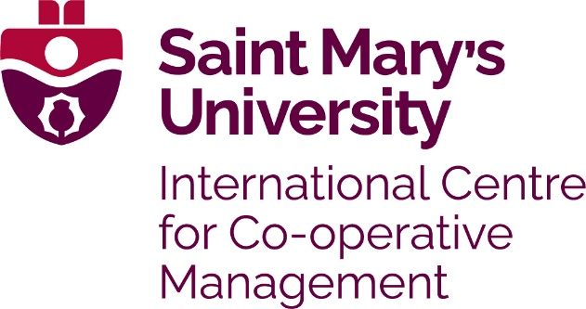

The International Centre for Co-operative Management (ICCM) at Saint Mary’s University has bursaries available to graduate students enrolled in their Master’s or Graduate Diploma programs. These annual awards will be directed to graduate students who demonstrate financial need. Additional bursary criteria are outlined below.

Dr. Sydney Pobihushchy Bursary

Established through the generosity of members of the Co-operative Management Education Co-operative (CMEC) and supporters of the Master of Management, Co-operatives and Credit Unions (MMCCU) program, the bursary was named in Honor of the late Dr. Sydney I Pobihushchy in 2007. Dr. Pobihushchy was a long time promoter of co-operative education, held undergraduate and honorary degrees from Saint Mary’s University, and was co-founder of the Co-operative Management Education program. Variable amounts are awarded based on applicant need and availability of funds on any given year.

Leadership in Co-operative Management Education Bursary

Through the generosity and support of the Co-operative Management Education Co-operative (CMEC), a bursary was established in 2014. There are designated funds within this bursary that support each Canadian, US and international applicants from co-operative organizations who might not otherwise be able to afford the program costs. Variable amounts are awarded based on applicant need and availability of funds on any given year. Thank you to the ongoing supporters including The Co-operators as well as Centre’s staff members, individual donors and alumni.

These awards are non-renewable; however, applicants may reapply each year.
Application deadline is May 31st
Note that only applicants with complete degree program applications will be considered for a bursary.

Contact Information:

Name:
Organization: |  | Title:
Address:
City: | Province/State:
Country: | Postal/Zip Code:
Telephone Number: | Email:

Indicate which bursary(ies) you are applying for:

Dr. Sydney I Pobihushchy Bursary
Leadership in Co-operative Management Education Bursary

In 500 words or less, please:
1) Describe your need for financial assistance and
2) Include the amount of funding you are requesting

ICCM Bursary awards are limited – full scholarships are not available. To help us determine your eligibility, please indicate other sources of funding you will rely on to cover program costs (other scholarships/bursaries you have applied for/received, amount of financial support from your co-operative, self-funding, etc.):

#1 | Amount $
#2 | Amount $
#3 | Amount $
#4 | Amount $

Signature of Applicant: Date:
The application form may be completed and returned electronically to erin.hancock@smu.ca

