Field Dimensions of the subject area | 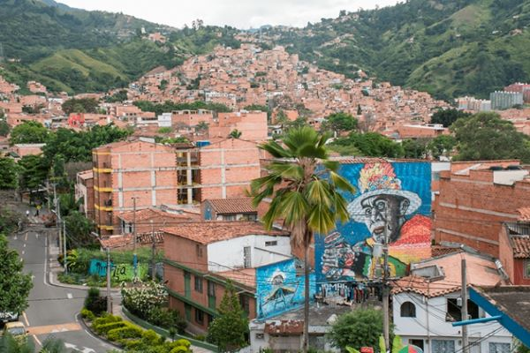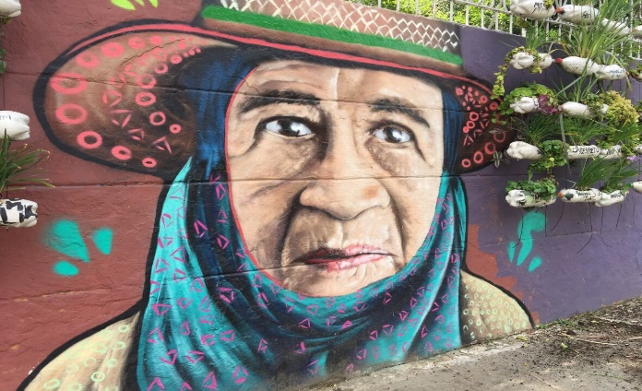
The purpose of this Field school is to introduce students of how different grassroots organizations work with historical memory, reconciliation, and peace projects in Colombia. Students will gain firsthand knowledge from and participate in different community projects in some of the areas most affected by the conflict in partnership with award-winning organizations like Agroarte Colombia (Medellín), Granada (Antioquia), Artesanas de amor (La Union, Antioquia). This is a unique opportunity for students in Global Development Studies, Political Sciences, Latin American Studies, and Hispanic Studies where they will gain firsthand knowledge from and participate in different community projects in some of the areas most affected by the conflict. Students will also visit public institutions related to historical memory such as Casa Museo de la Memoria in Medellin.
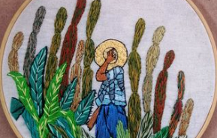
Field School Goals
- Acquire a broad panoramic of cultural production in Latin American countries, with special emphasis on Colombia, which portrays the resilience of its people and the literary, film and cultural production related to historical memory and post/conflict societies.
- Develop strategies to analyze testimonial and fictional fragments, documentaries, and films through the lens of some articles from different fields of study: Literary Studies, Gender and Sexuality Studies, Borderlands, and Sociology, among others.
- Demonstrate the ability to interpret and critique different Latin American cultures, and especially Colombia, through different types of texts and other authentic materials and reflect on how these topics relate to one’s own culture.
- Improve listening, reading, writing, and speaking in the target language through a variety of in-person activities and assignments required for this course

Daily Schedule in Colombia
From 8 a.m. to 12 p.m. students will attend lectures and work in discussion groups around different topics related to post-traumatic literature, Latin American Cultural production during some of the Latin American dictatorships, Central America armed conflict, regional peace agreements, post-conflict and historical memory with special emphasis in the Colombian armed conflict, the 2016 peace agreement between the Colombian Government and the FARC guerrillas, the truth commission report and testimonial literature. Lunch will be between 12 and 2 p.m. From 2 p.m. to 5 p.m., students will visit different community projects where they will be involved in community work with local leaders, peasants and members of communities affected by the armed conflict. They will share their stories where students will learn about different ways of community resilience and how different types of cultural productions and agricultural projects help them preserve historical memory and non-violence repetition.

From May 27-31, students will attend various lectures on Saint Mary's campus. They will arrive in Bogotá at El Dorado International Airport on June 2, where they will stay for three days. During their stay in Bogotá, students will visit important institutions such as the JEP Headquarters, the National History Museum, the Memory Center, Monserrate and the La Candelaria neighbourhood.

On June 3, students will travel from Bogotá to Medellín by plane. The lectures will take place in the different communities they visit from 8 a.m. to 5 p.m. m. to noon m., followed by lunch from noon m. to 1 p.m. In the afternoons, students will interact with community leaders in Comuna Trece (one of the districts of Medellín). Here, numerous cultural organizations collaborate with local communities on projects involving hip-hop, agricultural initiatives, dance, theatre, film, photography and creative writing to build narratives focused on community resilience, resistance and memory. Guest speakers from the University of Antioquia, Casa Kolacho, Moravia and Agroarte Colombia will contribute to these discussions.

The return flight to Canada is scheduled for June 15. The program covers approximately 150 hours of instruction and community work related to project participation.

Fees and Costs
The Field School in Colombia has a program fee of approx. CAD 1,500, which covers costs associated with the field school, including meals, accommodation, local transportation, museum tickets, guest speakers’ conferences and donations to local NGOs for two weeks.
Students are responsible for the additional costs of travel from Canada to Colombia. In general, airfare to and from Colombia during the summer runs between CAD 1,500 to $2,000 (depending on the point of departure, airline, and route). Students should also anticipate costs for travel and emergency health insurance.
Students should register for these two courses for the summer of 2024 sessions SPAN3777 and SPAN4400.

Contact information
Dr. Andres Arteaga, Department of Languages and Cultures, Saint Mary’s University; andres.arteaga@smu.ca
Telephone +1 (902) 420 5811

Application Process

If you are interested in applying to participate in the 2024 field school, please fill in this form and send it back by February 15th, 2024, to Dr. Andres Arteaga, Department of Languages and Culture, Saint Mary's University, Halifax, NS, Canada, via email at: andres.arteaga@smu.ca.

Application Process

Expression of Interest (DUE BY FEB 15TH , 2024)
Deposit of CAD$500 nonrefundable

Name: _________________________________ Phone: _______________________________________

A # (for Saint Mary’s Students only): ________________ Email: __________________________________

Address: ______________________________________________________________________________

Academic Background and Interests:
_____________________________________________________________________________________

_____________________________________________________________________________________

Use the room provided below to explain briefly why you are interested in participating in the field school. What do you expect to get out of the Field School in Colombia?

